**INDEX**

| **EXP NO** | **TITLE** | **PAGE No** | **DATE** | **SIGN** |
| --- | --- | --- | --- | --- |
| 1 | BASIC NETWORKING COMMANDS | 2 |  |  |
| 2 | CLIENT SERVER COMMUNICATION (SOCKET PROGRAMMING) | 7 |  |  |
| 3 | CODE FOR SIMULATING PING AND TRACEROUTE COMMANDS | 10 |  |  |
| 4 | CREATE SOCKET FOR HTTP, TO WEBPAGE UPLOAD AND DOWNLOAD | 12 |  |  |
| 5 | SIMULATION OF ERROR CORRECTION CODE (CRC) | 15 |  |  |
| 6 | IMPLEMENTATION OF STOP AND WAIT PROTOCOL | 17 |  |  |
| 7 | SIMULATION OF SLIDING WINDOW PROTOCOL | 21 |  |  |
| 8 | SIMULATING ARP PROTOCOLS | 26 |  |  |
| 9 | PROGRAM FOR REVERSE ADDRESS RESOLUTION PROTOCOL USING UDP | 29 |  |  |
| 10 | ECHO CLIENT AND ECHO SERVER | 33 |  |  |
| 11 | CHAT | 37 |  |  |
| 12 | FILE TRANSFER | 40 |  |  |
| 13 | SIMULATION OF DNS USING UDP SOCKETS | 43 |  |  |
| 14 | B. SNMP APPLICATION | 47 |  |  |

**EXPERIMENT-1**

**BASIC NETWORKING COMMANDS**

**AIM:** To implementbasic networking keywords

**PROCEDURE:**

1. Study the basic networking commands.

2. Run the networking commands along with their arguments and parameters.

3. Observe the output on the command line.

4. Record observations in the journal.2

**SOURCE CODE:**

1. Tracert :

The **tracert** command prints the path. If all routers on the path are functional, this command prints the full path. If a router is down on the path, this command prints the path up to the last operational router.

tracert [**www.google.co.in**](http://www.google.co.in)

1. Ping :

The **ping** command is used to test connectivity between two hosts.

ping **google.com**

1. **Arp :**

By default, this command displays the ARP table of the active NIC. If multiple NICs are installed on the computer, you can use the **-a** option with this command. If the -a option is used, the ARP command displays all ARP tables.

arp -a

1. **netstat :**

This command displays active connections, ports on which the computer is listening, Ethernet statistics, the IP routing table, and IP statistics.

Netstat

1. **Ipconfig :**

This command displays all current TCP/IP network configuration values and refreshes Dynamic Host Configuration Protocol (DHCP) and Domain Name System (DNS) settings. This command is mainly used to view the IP addresses on the computers that are configured to obtain their IP address automatically.

ipconfig

**OUTPUT:**

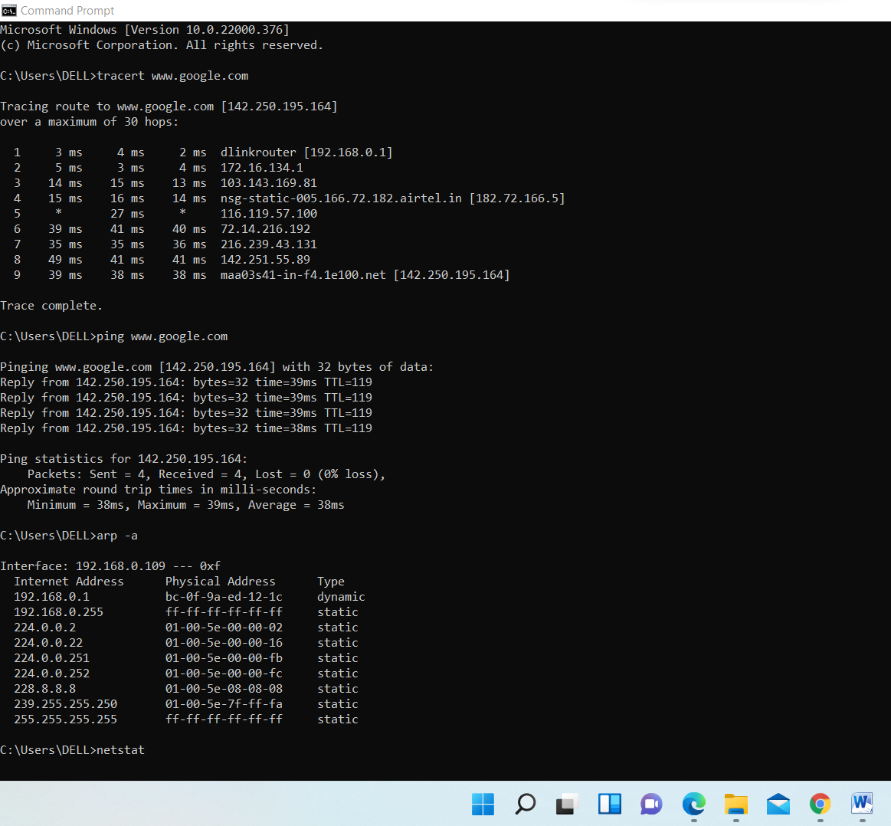

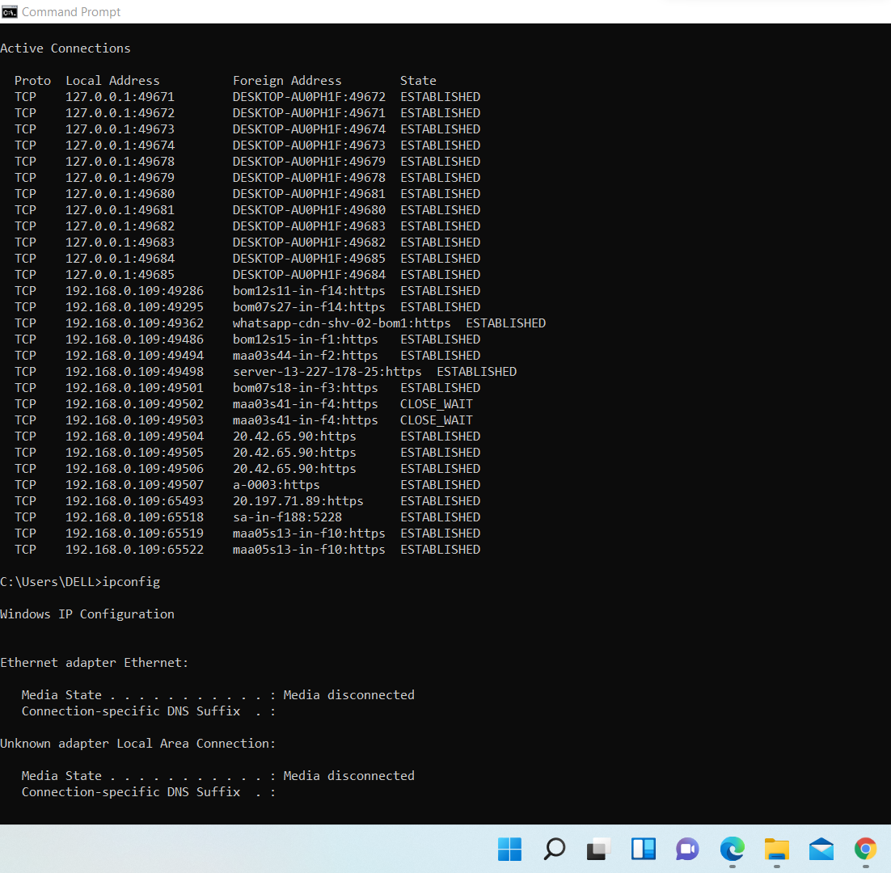

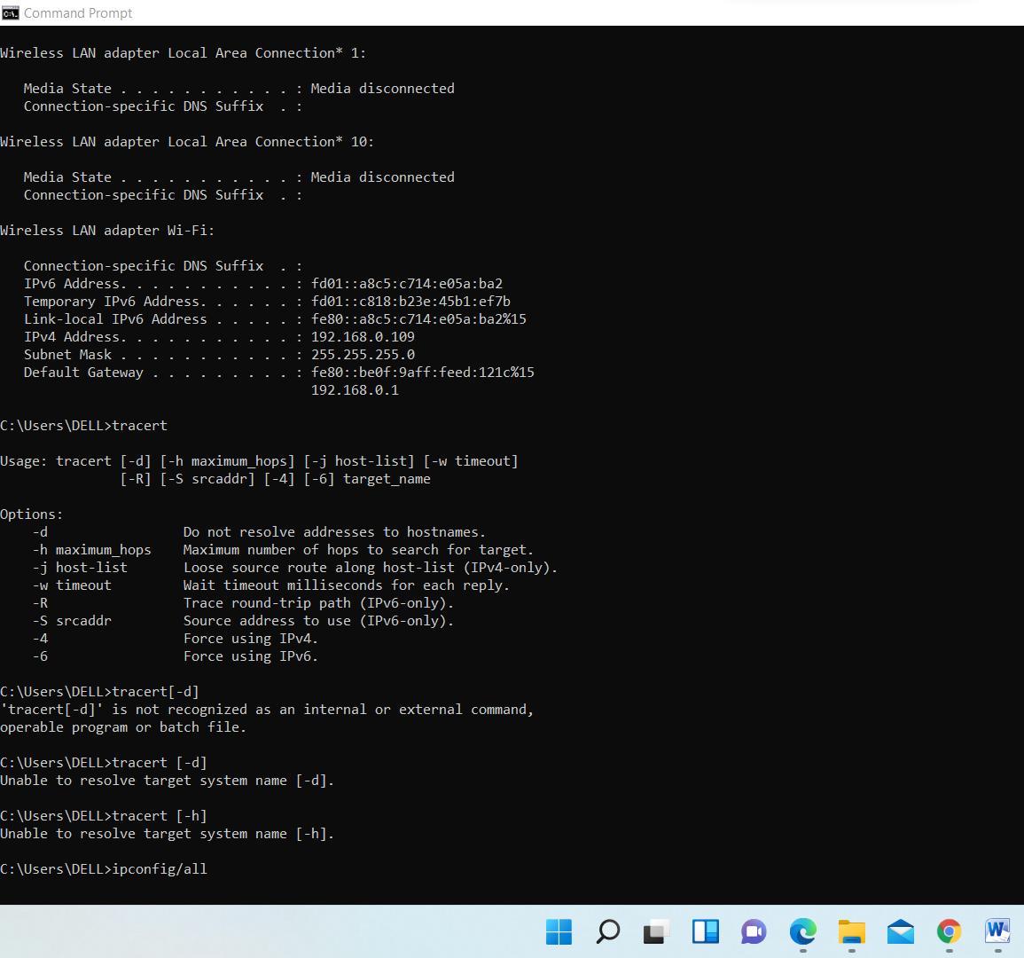

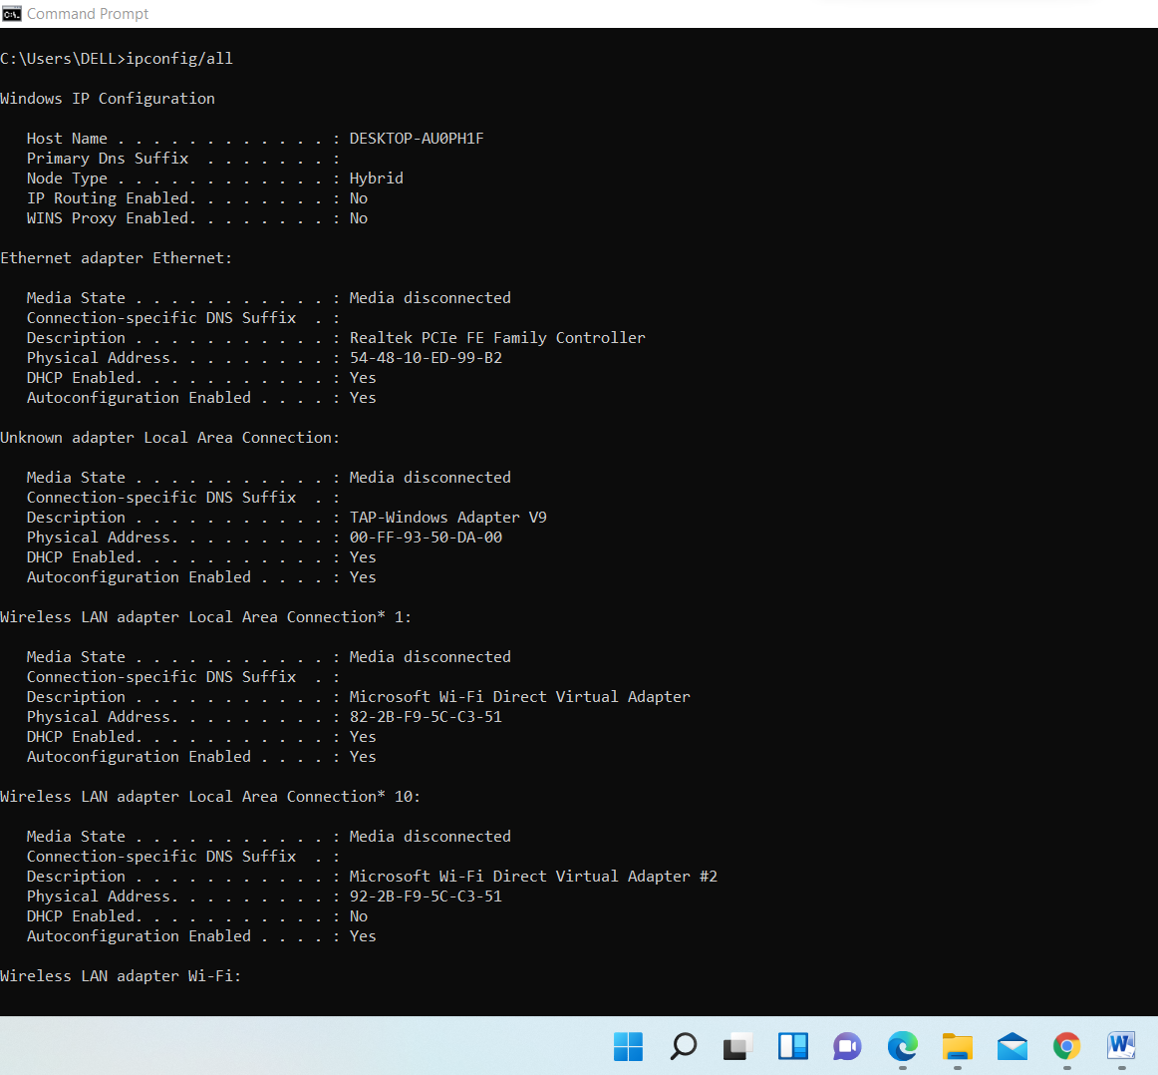

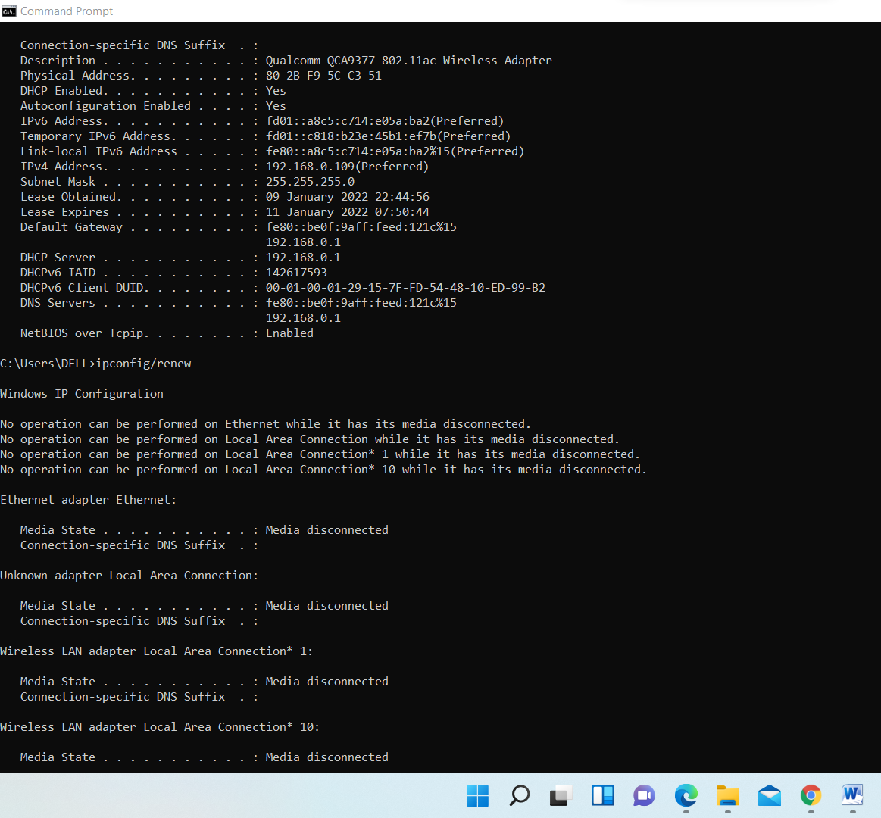

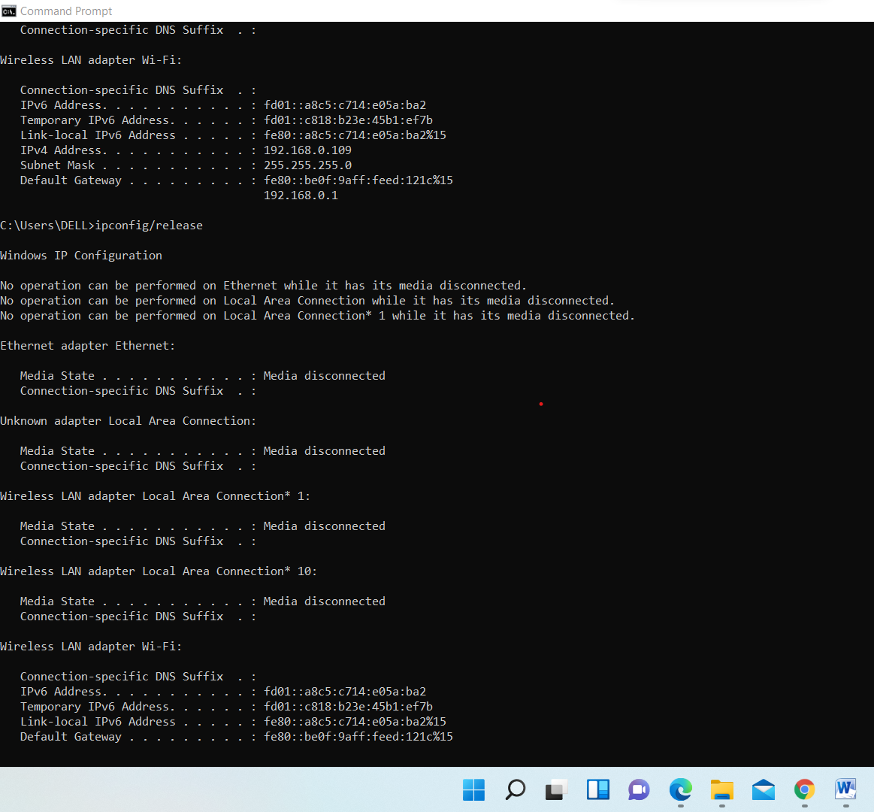

**RESULT:** Basic Networking Commands are implemented successfully.

**EXPERIMENT-2**

**CLIENT SERVER COMMUNICATION (SOCKET PROGRAMMING)**

**AIM:** To Implement Client Server Communication

**PROCEDURE:**

**CLIENT SIDE**

1. Start the program.

2. Create a socket which binds the Ip address of server and the port address to acquire service.

3. After establishing connection send a data to server.

4. Receive and print the same data from server.

5. Close the socket.

6. End the program.

**SERVER SIDE**

1. Start the program.

2. Create a server socket to activate the port address.

3. Create a socket for the server socket which accepts the connection.

4. After establishing connection receive the data from client.

5. Print and send the same data to client.

6. Close the socket.

7. End the program.

**SOURCE CODE:**

**Server**

import java.net.*;

import java.io.*;

import java.util.*;

class dateserver

{

public static void main(String args[])

{

ServerSocket ss;

Socket s;

PrintStream ps;

DataInputStream dis;

String inet;

try

{

ss = new ServerSocket(8020);

while (true)

{

s = ss.accept();

ps = new PrintStream(s.getOutputStream());

Date d = new Date();

ps.println(d);

dis = new DataInputStream(s.getInputStream());

inet = dis.readLine();

System.out.println("THE CLIENT SYSTEM ADDRESS IS:" + inet);

ps.close();

}

}

catch (IOException e)

{

System.out.println("The Exception is :" + e);

}

}

}

**Client**

import java.net.*;

import java.io.*;

class dateclient

{

public static void main(String[] args)

{

Socket soc;

DataInputStream dis;

String sdate;

PrintStream ps;

try

{

InetAddress ia=InetAddress.getLocalHost();

soc=new Socket(ia,8020);

dis=new DataInputStream(soc.getInputStream());

sdate=dis.readLine();

System.out.println("THE date in the server is:"+sdate);

ps=new PrintStream(soc.getOutputStream());

ps.println(ia);

}

catch(IOException e)

{

System.out.println("THE EXCEPTION is: "+e);

}

}

}

**OUTPUT:**

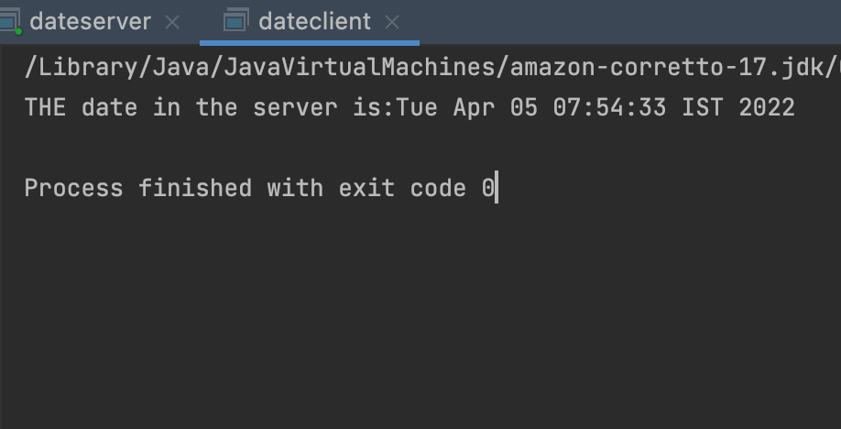

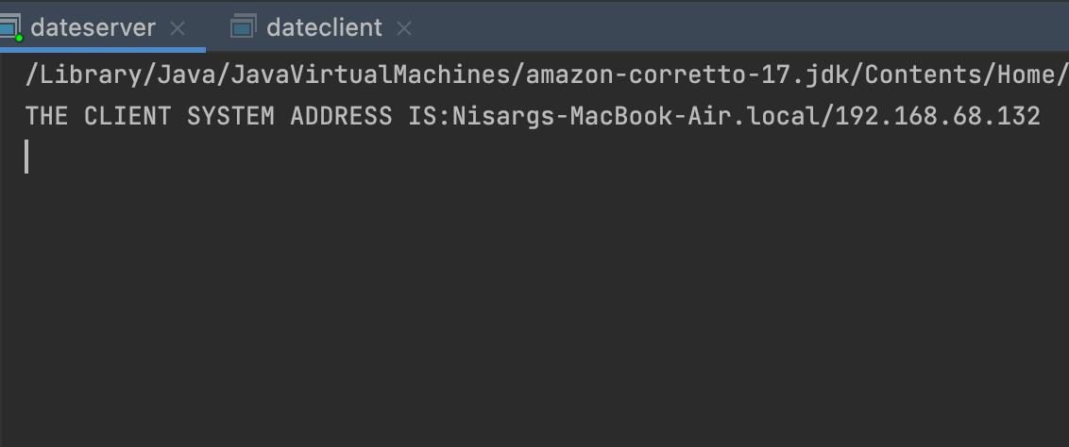

**RESULT:** Client Server Communication using socket programming has been implemented successfully.

**EXPERIMENT-3**

**CODE FOR SIMULATING PING AND TRACEROUTE COMMANDS**

**AIM:** To Write The java program for simulating ping and traceroute commands

**PROCEDURE:**

1.Start the program.

2.Get the frame size from the user

3.To create the frame based on the user request.

4.To send frames to server from the client side.

5.If your frames reach the server it will send ACK signal to client otherwise it will send NACK signal to client.

6.Stop the program

**SOURCE CODE:**

**Server**

import java.io.*;

import java.net.*;

class pingserver

{

public static void main(String args[])

{

try

{

String str;

System.out.print(" Enter the IP Address to be Ping : ");

DataInputStream dis=new DataInputStream(System.in);

String ip=dis.readLine();

Runtime H=Runtime.getRuntime();

Process p=H.exec("ping " + ip);

InputStream in=p.getInputStream();

DataInputStream buf2=new DataInputStream(in);

while((str=buf2.readLine())!=null)

{

System.out.println(" " + str);

}

}

catch(Exception e)

{

System.out.println(e.getMessage());

}

}}

**Client**

import java.io.*;

import java.net.*;

public class traceroutecmd

{

     public static void runSystemCommand(String command)

     {

          try

          {

              Process p = Runtime.getRuntime().exec(command);

DataInputStream inputstream=new DataInputStream(p.getInputStream());

              String s = "";

              while ((s = inputstream.readLine()) != null)

                   System.out.println(s);

          }

          catch (Exception e)

          {

          }}

     public static void main(String[] args)

     {

          String ip = "www.google.co.in";

          runSystemCommand("tracert " + ip);

     }

}

**OUTPUT**

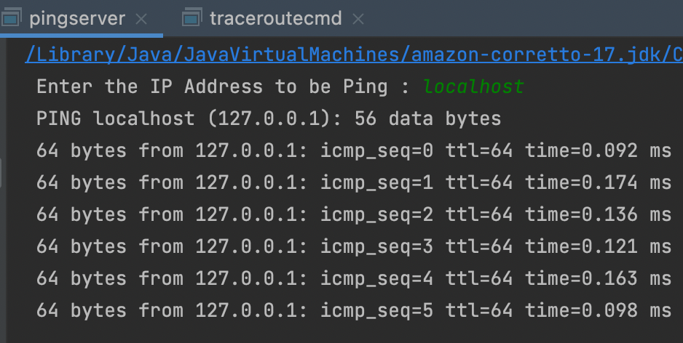

**RESULT:**

Thus the program was implementing to simulating ping and traceroute commands.

**EXPERIMENT-4**

**CREATE SOCKET FOR HTTP,TO WEBPAGE UPLOAD AND DOWNLOAD**

**AIM:** To write a java program for socket for HTTP for web page upload and download .

**PROCEDURE:**

1.Start the program.

2.Get the frame size from the user

3.To create the frame based on the user request.

4.To send frames to server from the client side.

5.If your frames reach the server it will send ACK signal to client otherwise it will send NACK signal to client.

6.Stop the program

**SOURCE CODE:**

**Server**

import java.net.*;

import java.io.*;

import java.awt.image.*;

import javax.imageio.*;

import javax.swing.*;

class Server {

public static void main(String args[]) throws Exception{

ServerSocket server=null;

Socket socket;

server=new ServerSocket(4000);

System.out.println("Server Waiting for image");

socket=server.accept(); System.out.println("Client connected.");

InputStream in = socket.getInputStream();

DataInputStream dis = new DataInputStream(in);

int len = dis.readInt();

System.out.println("Image Size: " + len/1024 + "KB"); byte[] data = new byte[len];

dis.readFully(data);

dis.close();

in.close();

InputStream ian = new ByteArrayInputStream(data);

BufferedImage bImage = ImageIO.read(ian);

JFrame f = new JFrame("Server");

ImageIcon icon = new ImageIcon(bImage);

JLabel l = new JLabel();

l.setIcon(icon);

f.add(l);

f.pack();

f.setVisible(true);

}}

**Client**

import javax.swing.*;

import java.net.*;

import java.awt.image.*;

import javax.imageio.*;

import java.io.*;

import java.awt.image.BufferedImage;

import java.io.ByteArrayOutputStream;

import java.io.File;

import java.io.IOException; import

javax.imageio.ImageIO;

public class Client{

public static void main(String args[]) throws Exception{

Socket soc;

BufferedImage img = null;

soc=new Socket("localhost",4000);

System.out.println("Client is running. ");

try {

System.out.println("Reading image from disk. ");

img = ImageIO.read(new File("dog.jpg"));

ByteArrayOutputStream baos = new ByteArrayOutputStream();

ImageIO.write(img, "jpg", baos);

baos.flush();

byte[] bytes = baos.toByteArray();

baos.close();

System.out.println("Sending image to server. ");

OutputStream out = soc.getOutputStream();

DataOutputStream dos = new DataOutputStream(out);

dos.writeInt(bytes.length);

dos.write(bytes, 0, bytes.length);

System.out.println("Image sent to server. ");

dos.close();

out.close();

}catch (Exception e) { System.out.println("Exception: " + e.getMessage());

soc.close();

}

soc.close();

}}

**OUTPUT**

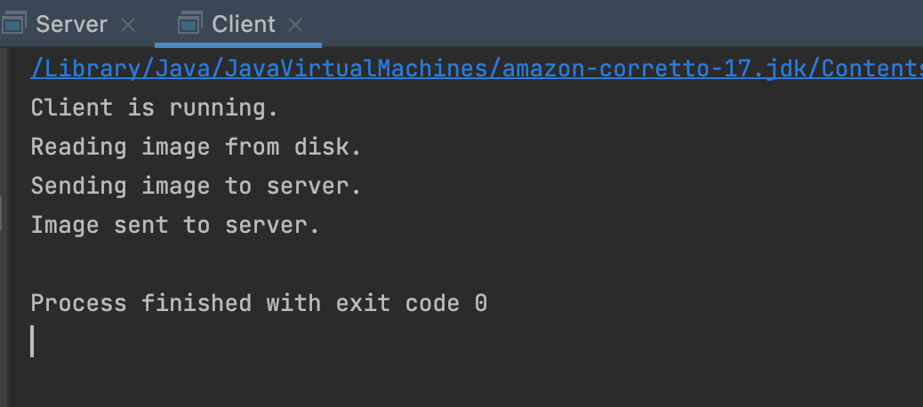

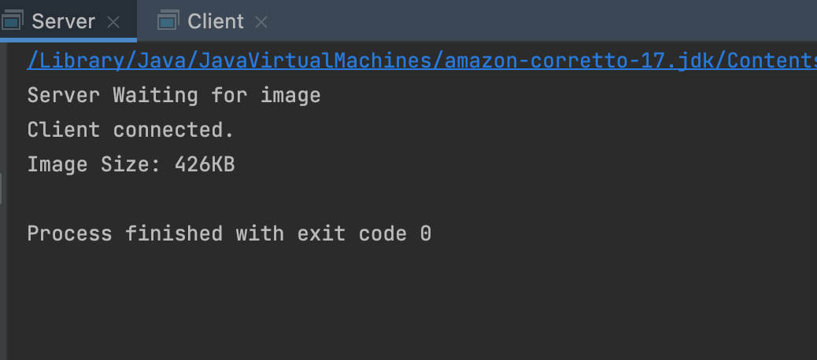

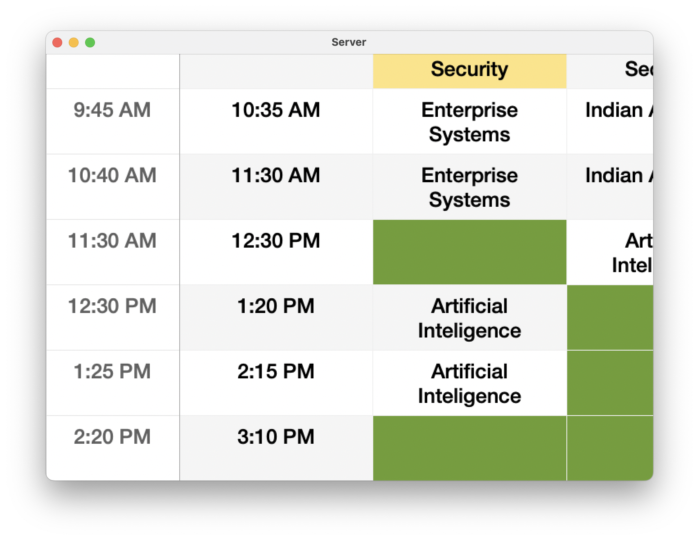

**RESULT:** Thus the program was implementing to socket for HTTP for web page upload and download.

**EXPERIMENT-5**

**SIMULATION OF ERROR CORRECTION CODE (CRC)**

**AIM:** To Simulation of Error Correction Code using C++

**PROCEDURE:**

1. Open the editor and type the program for error detection

2. Get the input in the form of bits.

3. Append the redundancy bits.

4. Divide the appended data using a divisor polynomial.

5. The resulting data should be transmitted to the receiver.

6. At the receiver the received data is entered.

7. The same process is repeated at the receiver.

8. If the remainder is zero there is no error otherwise there is some error in the received bits

9. Run the program.

**SOURCE CODE:**

import java.io.*;

class CRC

{

public static void main(String args[]) throws IOException

{

 System.out.println("Enter Generator:");

 DataInputStream br=new DataInputStream(System.in);

 String gen = br.readLine();

 System.out.println("Enter Data:");

 String data = br.readLine();

 String code = data;

 while(code.length() < (data.length() + gen.length() - 1))

{

 code = code + "0";

}

code = data + div(code,gen);

 System.out.println("The transmitted Code Word is: " + code);

 System.out.println("Please enter the received Code Word: ");

 String rec = br.readLine();

 if(Integer.parseInt(div(rec,gen)) == 0)

 System.out.println("The received code word contains no errors.");

 else

 System.out.println("The received code word contains errors.");

}

static String div(String num1,String num2)

{

 int pointer = num2.length();

 String result = num1.substring(0, pointer);

 String remainder = "";

 for(int i = 0; i < num2.length(); i++)

 {

 if(result.charAt(i) == num2.charAt(i))

 remainder += "0";

 else

 remainder += "1";

 }

 while(pointer < num1.length())

 {

 if(remainder.charAt(0) == '0')

 {

 remainder = remainder.substring(1, remainder.length());

 remainder = remainder + String.valueOf(num1.charAt(pointer));

 pointer++;

 }

 result = remainder;

 remainder = "";

 for(int i = 0; i < num2.length(); i++)

 {

 if(result.charAt(i) == num2.charAt(i))

 remainder += "0";

 else

 remainder += "1";

 }

 }

 return remainder.substring(1,remainder.length());

}

}

**OUTPUT:**

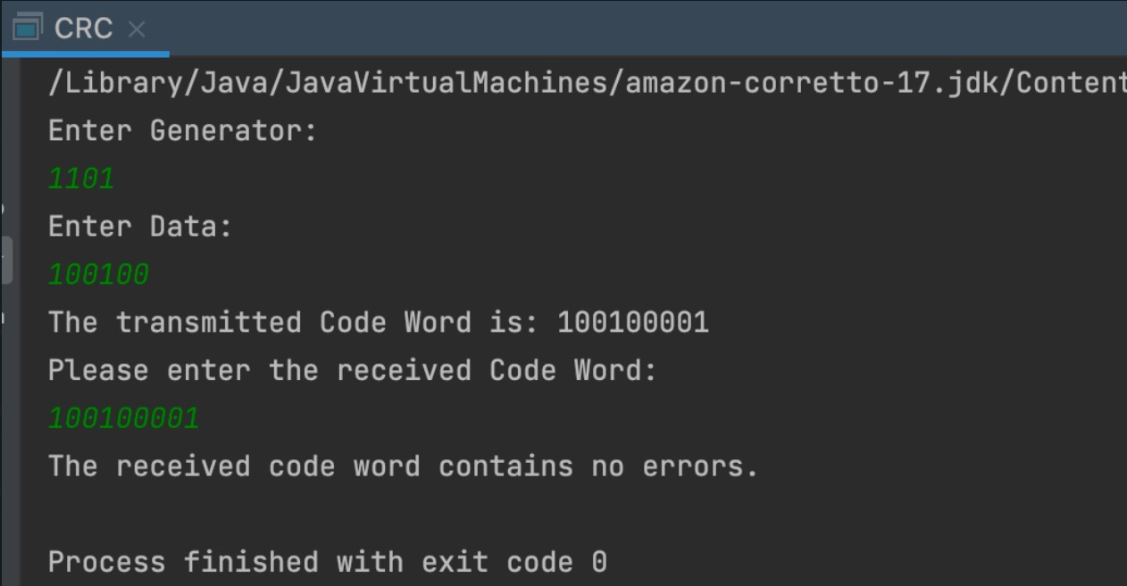

**RESULT:** Thus the error detection and error correction is implemented successfully.

**EXPERIMENT-6**

**IMPLEMENTATION OF STOP AND WAIT PROTOCOL**

**AIM:**  To write a java program to perform stop and wait protocol

**PROCEDURE:**

1.Start the program.

2.Get the frame size from the user

3.To create the frame based on the user request.

4.To send frames to server from the client side.

5.If your frames reach the server it will send ACK signal to client otherwise it will send NACK signal to client.

6.Stop the program

**SOURCE CODE:**

**Server**

import java.io.*;

import java.net.*;

import java.util.*;

public class receiver {

    public static void main(String args[])

{

    String h="Serverhost";

    int q=5000;

    int i;

        try

        {

        ServerSocket ss2;

            ss2 = new ServerSocket(8000);

            Socket s1 =ss2.accept();

        DataInputStream dd1= new DataInputStream(s1.getInputStream());

        Integer i1 =dd1.read();

        for(i=0;i<i1;i++)

        {

            ServerSocket ss1;

            ss1 = new ServerSocket(9000+i);

            Socket s =ss1.accept();

        DataInputStream dd= new DataInputStream(s.getInputStream());

        String sss1 = dd.readUTF();

            System.out.println(sss1);

            System.out.println("Frame "+ i+" received");

        DataOutputStream d1 = new DataOutputStream(s.getOutputStream());

        d1.write(i);

         System.out.println("ACK sent for "+ i);

        }

        }

        catch(Exception ex)

        {

         System.out.println("Error"+ex);

                }

}

}

**Client**

import java.io.*;

import java.net.*;

import java.util.Scanner;

public class sender {

public static void main(String args[])

{

   int p=9000,i,q=8000;

    String h="localhost";

    try

    {

    Scanner scanner = new Scanner(System.in);

    System.out.print("Enter number of frames : ");

    int number = scanner.nextInt();

    if(number==0)

    {

        System.out.println("No frame is sent");

    }

    else

            {

          Socket s2= new Socket(h,q);

        DataOutputStream d1 = new DataOutputStream(s2.getOutputStream());

        d1.write(number);

          }

    String str1;

        for (i=0;i<number;i++)

        {

    System.out.print("Enter message : ");

    String name = scanner.next();

    System.out.println("Frame " + i+" is sent");

    Socket s1;

        s1= new Socket(h,p+i);

        DataOutputStream d = new DataOutputStream(s1.getOutputStream());

        d.writeUTF(name);

        DataInputStream dd= new DataInputStream(s1.getInputStream());

        Integer sss1 = dd.read();

        System.out.println("Ack for :" + sss1 + " is  received");

        }

    }

    catch(Exception ex)

            {

                System.out.println("ERROR :"+ex);

            }

}

}

**OUTPUT:**

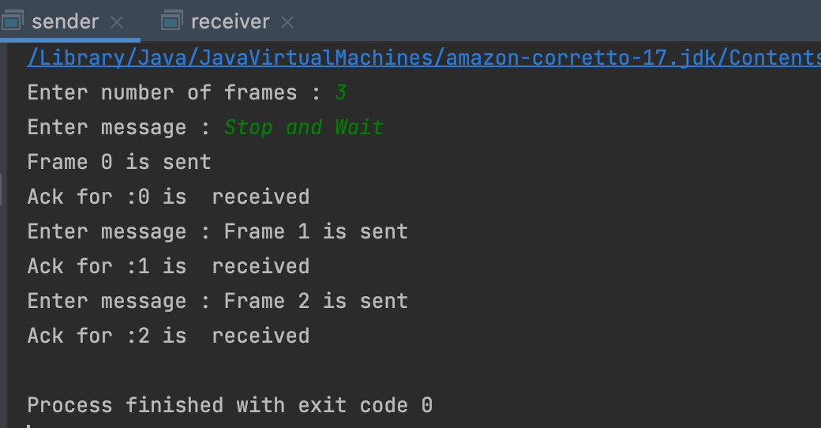

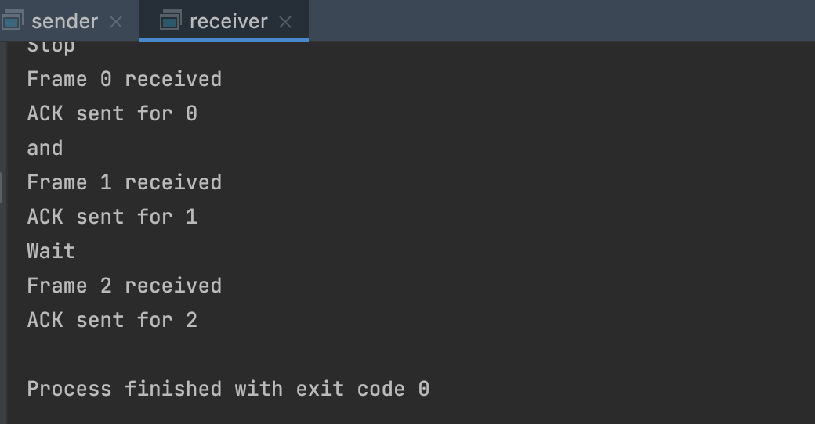

**RESULT:** Thus the program for implementing stop and wait protocol was executed successfully.

**EXPERIMENT-7**

**SIMULATION OF SLIDING WINDOW  PROTOCOL**

**AIM:** To ImplementSimulation of Sliding Window Protocol

**PROCEDURE:**

1. Start the program.

2. Get the frame size from the user

3. To create the frame based on the user request.

4. To send frames to the server from the client-side.

5. If your frames reach the server it will send ACK signal to client otherwise

it will send a NACK signal to the client.

6. Stop the program

**SOURCE CODE:**

**Server**

import java.io.*;

import java.net.*;

public class slidesserver

{

public static void main(String args[])throws IOException

{

byte msg[]=new byte[200];

ServerSocket ser=new ServerSocket(2000);

Socket s;

PrintStream pout;

DataInputStream in=new DataInputStream(System.in);

int start,end,l,j=0,i,ws=5,k=0;

String st,stl[]=new String[100];

System.out.println("Type\"Stop\"to exit");

s=ser.accept();

pout=new PrintStream(s.getOutputStream());

DataInputStream rin=new DataInputStream(s.getInputStream());

System.out.println("enter data to be send:");

while(true)

{

st=in.readLine();

l=st.length();

start=0;

end=10;

j=0;

if(st.equals("STOP"))

{

pout.println(st);

break;

}

if(l<10)

{stl[j++]=l+st;

}

else

{

for(i=l,j=0;i>0;i=i-10,j++)

{

stl[j]=(j+1)+st.substring(start,end);

start=end;

end=end+10;

if(end>l)

{

end=((start-10)+i);

}}

System.out.println("total number of packet"+j);

}

pout.println(j);

for(i=0;i<j;i++)

{

pout.println(stl[i]);

if((i+1)%ws==0)

{

System.out.println(rin.readLine());

}}

if(i%ws!=0)

{

System.out.println(rin.readLine());

System.out.println("enter next data to send");

}

}}}

**Client**

import java.io.*;

import java.net.*;

public class slideclient

{

            public static void main(String args[])throws IOException

            {

                 byte msg[]=new byte[200];

                 Socket s=new Socket(InetAddress.getLocalHost(),2000);

                 DataInputStream in=new DataInputStream(s.getInputStream());

                 DataInputStream ain=new DataInputStream(System.in);

                 PrintStream p=new PrintStream(s.getOutputStream());

                 char ch;

                 int i=0,ws=5;

                 while(true)

                 {

                           String str,astr;

                           int j=0;

                                    i=0;

                           str=in.readLine();

                           if(str.equals("STOP"))

                                     System.exit(0);

                           j=Integer.parseInt(str);

                           for(i=0;i<j;i++)

                           {

                                     str=in.readLine();

                                     System.out.println(str);

                                     if((i+1)%ws==0)

                                     {

                                               System.out.println("Give the ack by press\"Enter\"key");

                                               astr=ain.readLine();

                                               p.println((i+1)+"ack");

                                     }}

                           if((i%ws)!=0)

                           {

                                     System.out.println("Give the ack by press\"Enter\"key");

                                     astr=ain.readLine();

                                     p.println(i+"ack");}

                           System.out.println("All data are recieved and ack");

                 }}}

**OUTPUT:**

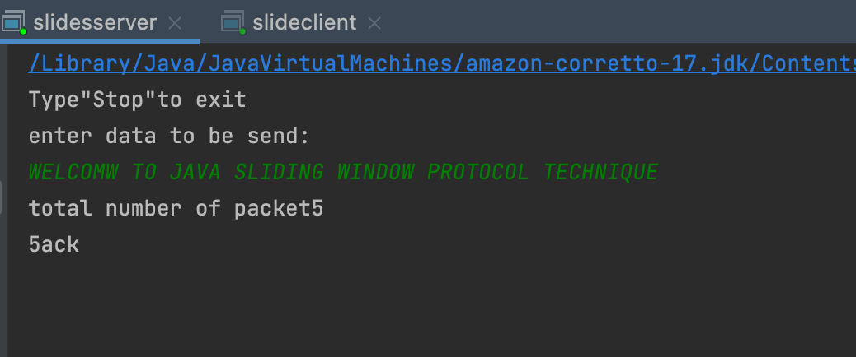

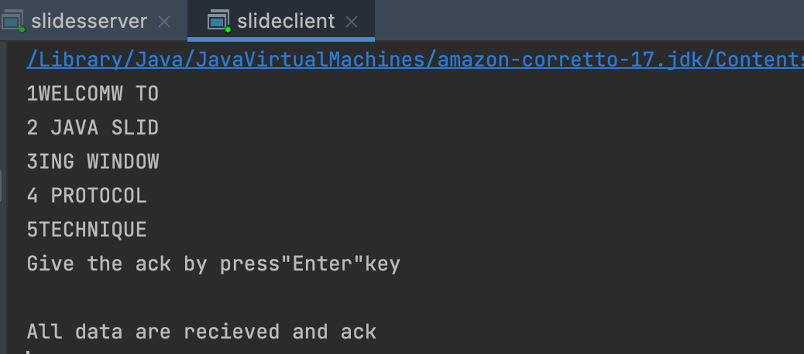

**RESULT:**  Thus, the above program sliding window protocol was executed and successfully.

**EXPERIMENT-8**

**SIMULATING ARP PROTOCOLS**

**AIM:** To write a java program for simulating ARP protocols using TCP

**PROCEDURE:**

**CLIENT-SIDE**

1. Start the program

2. Using socket connection is established between client and server.

3. Get the IP address to be converted into MAC address.

4. Send this IP address to the server.

5. Server returns the MAC address to the client.

**SERVER-SIDE**

1. Start the program

2. Accept the socket which is created by the client.

3. Server maintains the table in which IP and corresponding MAC addresses are stored.

4. Read the IP address which is sent by the client.

5. Map the IP address with its MAC address and return the MAC address to the client.

**SOURCE CODE:**

**Server**

import java.io.*;

import java.net.*;

import java.util.*;

 class Serverarp

{

public static void main(String args[])

{

try{

ServerSocket obj=new ServerSocket(139);

Socket obj1=obj.accept();

while(true)

{

DataInputStream din=new DataInputStream(obj1.getInputStream());

DataOutputStream dout=new DataOutputStream(obj1.getOutputStream());

 String str=din.readLine();

String ip[]={"165.165.80.80","165.165.79.1"};

String mac[]={"6A:08:AA:C2","8A:BC:E3:FA"};

for(int i=0;i<ip.length;i++)

{

 if(str.equals(ip[i]))

{

dout.writeBytes(mac[i]+'\n'); break;

}

}

obj.close();

}

}

catch(Exception e)

{

System.out.println(e);

} } }

**Client**

import java.io.*;

 import java.net.*;

 import java.util.*;

 class Clientarp

{

public static void main(String args[])

{

try{

BufferedReader in=new BufferedReader(new InputStreamReader(System.in));

Socket clsct=new Socket("127.0.0.1",139);

DataInputStream din=new DataInputStream(clsct.getInputStream());

 DataOutputStream dout=new DataOutputStream(clsct.getOutputStream()); System.out.println("Enter the Logical address(IP):");

String str1=in.readLine(); dout.writeBytes(str1+'\n');

String str=din.readLine();

System.out.println("The Physical Address is: "+str);

clsct.close();}

catch (Exception e){

System.out.println(e);

}}}

**OUTPUT:**

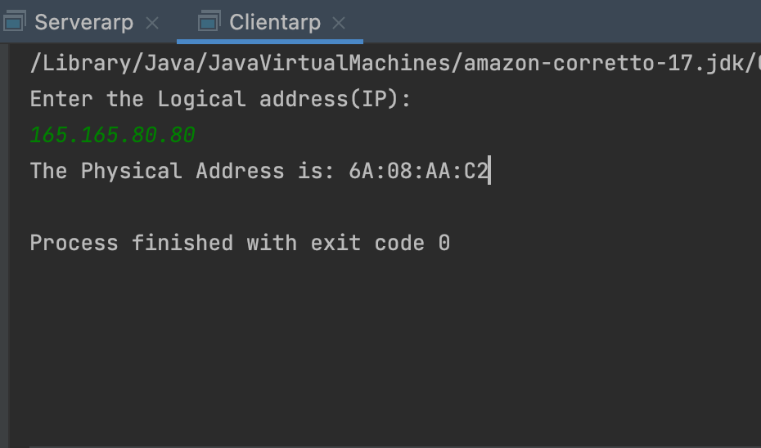

**RESULT:** Java program for simulating ARP protocols using TCP have been executed successfully.

**EXPERIMENT-9**

**Program for Reverse Address Resolution Protocol (RARP) using UDP**

**AIM:** To write a java program for simulating RARP protocols using DCP

**PROCEDURE:**

**CLIENT SIDE**

1. Start the program

2. using datagram sockets UDP function is established.

2.Get the MAC address to be converted into IP address.

3.Send this MAC address to server.

4.Server returns the IP address to client..

**SERVER SIDE**

1. Start the program

2. Accept the socket which is created by the client.

3. Server maintains the table in which IP and corresponding MAC addresses are stored.

4. Read the IP address which is sent by the client.

5. Map the IP address with its MAC address and return the MAC address to the client.

**SOURCE CODE:**

**Server**

import java.io.*;

 import java.net.*;

 import java.util.*;

class Serverrarp12

{

public static void main(String args[]){

try{

DatagramSocket server=new DatagramSocket(1309);

 while(true)

{

byte[] sendbyte=new byte[1024];

byte[] receivebyte=new byte[1024];

DatagramPacket receiver=new DatagramPacket(receivebyte,receivebyte.length); server.receive(receiver);

String str=new String(receiver.getData());

 String s=str.trim();

InetAddress addr=receiver.getAddress();

 int port=receiver.getPort();

String ip[]={"165.165.80.80","165.165.79.1"};

String mac[]={"6A:08:AA:C2","8A:BC:E3:FA"};

for(int i=0;i<ip.length;i++)

{

if(s.equals(mac[i]))

{

sendbyte=ip[i].getBytes();

DatagramPacket sender=newDatagramPacket(sendbyte,sendbyte.length,addr,port);

server.send(sender); break;

}

}

break;

}

}

catch(Exception e)

{

System.out.println(e);

}

}

}

**Client**

import java.io.*;

 import java.net.*;

 import java.util.*;

class Clientrarp12{

public static void main(String args[]){

try{

DatagramSocket client=new DatagramSocket();

InetAddress addr=InetAddress.getByName("127.0.0.1");

byte[] sendbyte=new byte[1024];

byte[] receivebyte=new byte[1024];

BufferedReader in=new BufferedReader(new InputStreamReader(System.in)); System.out.println("Enter the Physical address (MAC):")

String str=in.readLine();

 sendbyte=str.getBytes();

DatagramPacket sender=newDatagramPacket(sendbyte,sendbyte.length,addr,1309);

client.send(sender);

DatagramPacket receiver=new DatagramPacket(receivebyte,receivebyte.length);

client.receive(receiver);

String s=new String(receiver.getData());

 System.out.println("The Logical Address is(IP): "+s.trim());

 client.close();

}

catch(Exception e)

{

System.out.println(e);

}}}

**OUTPUT:**

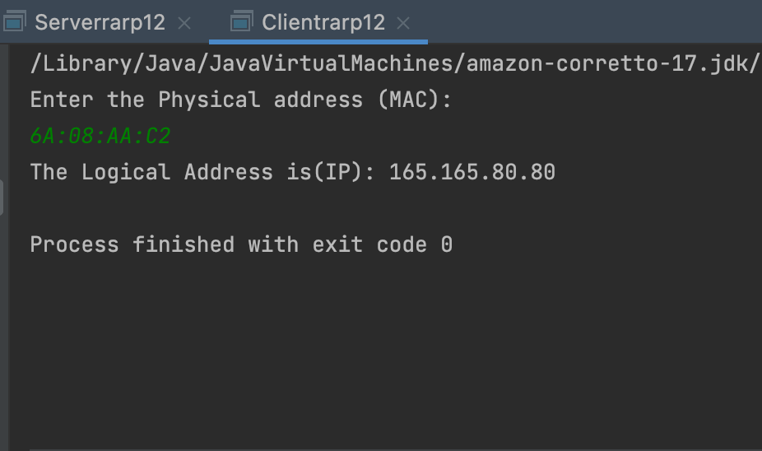

**RESULT:**  Java program for simulating RARP protocols using DCP has been implemented successfully

**EXPERIMENT-10**

**APPLICATIONS USING TCP SOCKETS**

**Echo client and Echo server**

**AIM:** To write a java program for application using TCP Sockets Links

**PROCEDURE:**

1. Start the program.

2. Get the frame size from the user

3. To create the frame based on the user request.

4. To send frames to server from the client side.

5. If your frames reach the server it will send ACK signal to client otherwise it

will send NACK signal to client.

6. Stop the program

**SOURCE CODE:**

**Server**

import java.net.*;

import java.io.*;

public class EServer

{

public static void main(String args[])

{

ServerSocket s=null;

String line;

DataInputStream is;

PrintStream ps;

Socket c=null;

try

{

s=new ServerSocket(9000);

}

catch(IOException e)

{

}

try

{

System.out.println(e);

c=s.accept();

is=new DataInputStream(c.getInputStream());

ps=new PrintStream(c.getOutputStream());

while(true)

{

line=is.readLine();

ps.println(line);

}

}

catch(IOException e)

{

System.out.println(e);

}

}

}

**Client**

import java.net.*;

import java.io.*;

public class EClient

{

public static void main(String arg[])

{

Socket c=null;

String line;

DataInputStream is,is1;

PrintStream os;

try

{

InetAddress ia = InetAddress.getLocalHost();

c=new Socket(ia,9000);

}

catch(IOException e)

{

}

try

{

System.out.println(e);

os=new PrintStream(c.getOutputStream());

is=new DataInputStream(System.in);

is1=new DataInputStream(c.getInputStream());

while(true)

{

System.out.println("Client:");

line=is.readLine();

os.println(line);

System.out.println("Server:" + is1.readLine());

}

catch(IOException e)

{

System.out.println("Socket Closed!");

 }

} }

**OUTPUT:**

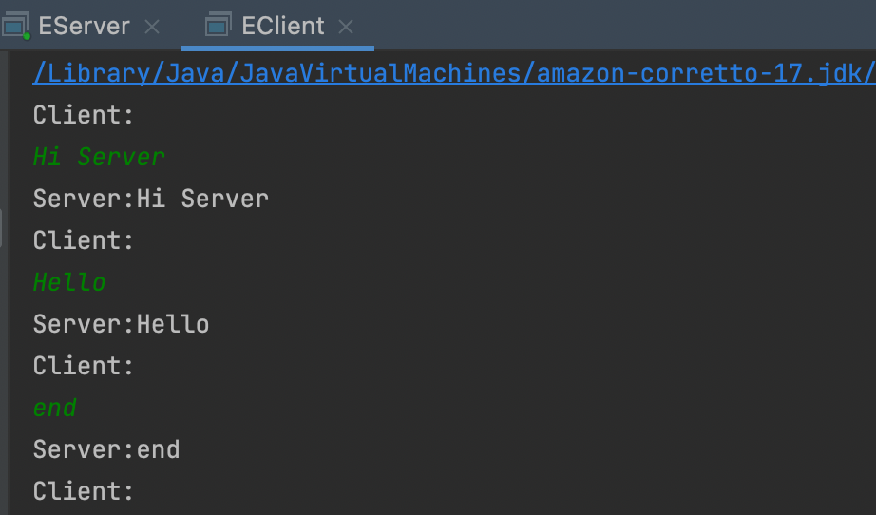

**RESULT:** Java program for application using TCP Sockets Links is implemented successfully

**EXPERIMENT-11**

**CHAT**

**AIM:** Write a Program client –server application for chat using UDP Sockets

**PROCEDURE:**

1. Start the program.

2.  Run UDPserver.java

3. Enter message from server

4. Run UDPclient.java

5. Enter message from client.

6. Stop the program

**SOURCE CODE:**

**Server**

import java.io.*;

import java.net.*;

class UDPserver

{

public static DatagramSocket ds;

public static byte buffer[]=new byte[1024];

public static int clientport=789,serverport=790;

public static void main(String args[])throws Exception

{

ds=new DatagramSocket(clientport);

System.out.println("press ctrl+c to quit the program");

BufferedReader dis=new BufferedReader(new InputStreamReader(System.in));

InetAddress ia=InetAddress.geyLocalHost();

while(true)

{

DatagramPacket p=new DatagramPacket(buffer,buffer.length);

ds.receive(p);

String psx=new String(p.getData(),0,p.getLength());

System.out.println("Client:" + psx); System.out.println("Server:");

String str=dis.readLine();

if(str.equals("end"))

break;

buffer=str.getBytes();

ds.send(newDatagramPacket(buffer,str.length(),ia,serverport));

}}}

**Client**

import java .io.*;

import java.net.*;

class UDPclient{

public static DatagramSocket ds;

public static int clientport=789,serverport=790;

public static void main(String args[])throws Exception

{ byte buffer[]=new byte[1024];

ds=new DatagramSocket(serverport);

BufferedReader dis=new BufferedReader(new InputStreamReader(System.in));

System.out.println("server waiting");

InetAddress ia=InetAddress.getLocalHost();

while(true)

{ System.out.println("Client:");

String str=dis.readLine();

if(str.equals("end"))

break;

buffer=str.getBytes();

ds.send(new DatagramPacket(buffer,str.length(),ia,clientport));

DatagramPacket p=new DatagramPacket(buffer,buffer.length);

ds.receive(p);

String psx=new String(p.getData(),0,p.getLength());

System.out.println("Server:" + psx);

}}}

**OUTPUT:**

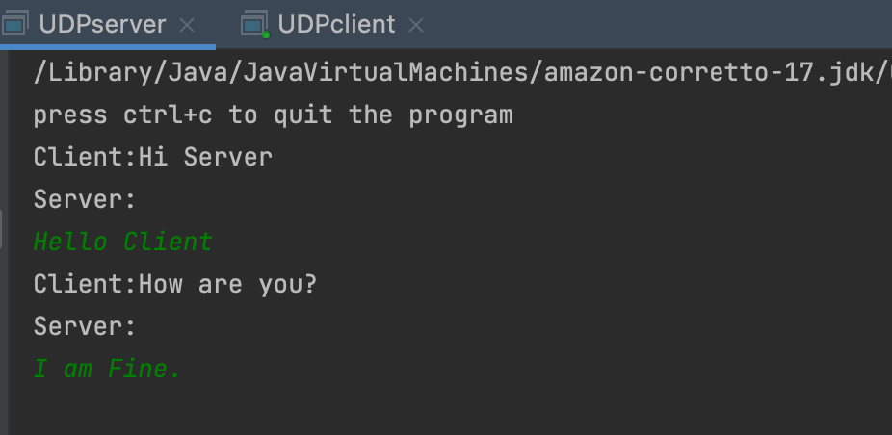

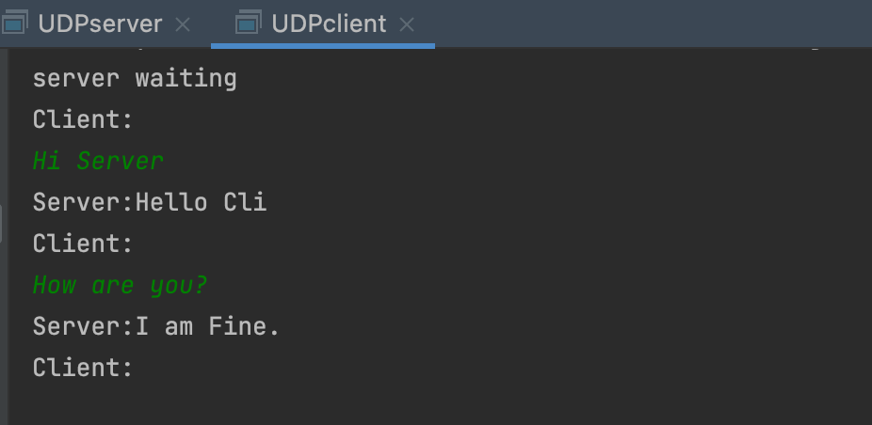

**RESULT:** Thus, the client –server application for chat using UDP Sockets is implemented successfully.

**EXPERIMENT-12**

**FILE TRANSFER**

**AIM:** Write a program for transferring of files from client to server

**PROCEDURE:**

1. Start the program.

2.  Run Serverfile.java

3. Enter some text and store it the sample.text

4. Run ClientFile and write the file name you want to view

5. Text will be retrieved.

6. Stop the program

**SOURCE CODE:**

**Client**

import java.io.*;

import java.net.*;

import java.util.*;

class Clientfile

{ public static void main(String args[])

{

Try

{

BufferedReader in=new BufferedReader(new

InputStreamReader(System.in)); Socket clsct=new Socket(&quot;127.0.0.1&quot;,139);

DataInputStream din=new DataInputStream(clsct.getInputStream());

DataOutputStream dout=new DataOutputStream(clsct.getOutputStream());

System.out.println("Enter the new file name:");

String str=in.readLine();

dout.writeBytes(str+'\n'); System.out.println("Enter the new file name:");

String str2=in.readLine();

String str1,ss;

FileWriter f=new

FileWriter(str2); char buffer[];

while(true)

{ str1=din.readLine();

if(str1.equals("-1")) break;

System.out.println(str1);

buffer=new char[str1.length()];

str1.getChars(0,str1.length(),buffer,0);

f.write(buffer);

}

f.close();

clsct.close();

}

catch (Exception e)

{ System.out.println(e);

}}}

**Server**

import java.io.*;

import java.net.*;

import java.util.*;

class Serverfile

{ public static void main(String args[])

{

Try

{ ServerSocket obj=new ServerSocket(139);

while(true)

{ Socket obj1=obj.accept();

DataInputStream din=new DataInputStream(obj1.getInputStream());

DataOutputStream dout=new DataOutputStream(obj1.getOutputStream());

String str=din.readLine();

FileReader f=new FileReader(str);

BufferedReader b=new BufferedReader(f);

String s;

while((s=b.readLine())!=null) {

System.out.println(s);

dout.writeBytes(s+'\n');

f.close();

dout.writeBytes("-1\n");} }

catch(Exception e)

{ System.out.println(e);}

}}

**OUTPUT:**

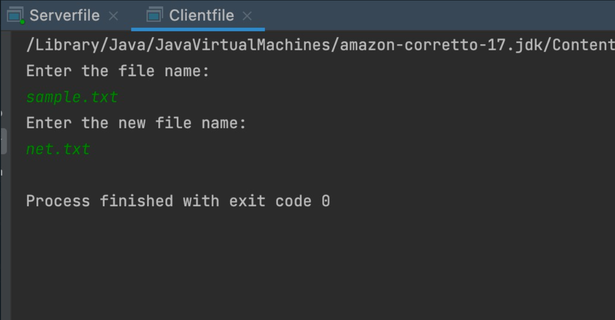

**RESULT:** Thus the transferring of files from client to server is implemented successfully.

**EXPERIMENT-13**

**Simulation of DNS using UDP sockets**

**AIM:** To write a java program for DNS application

**PROCEDURE:**

1.   Start the program.

2.   Get the frame size from the user.

3.   To create the frame based on the user request.

4.   To send frames to server from the client side.

5.   If your frames reach the server it will send ACK signal to client   otherwise it will send NACK signal to client.

6.  Stop the program.

**SOURCE CODE:**

**Server**

import java.io.*;

import java.net.*;

public class udpdnsserver

{

private static int indexOf(String[] array, String str)

{

str = str.trim();

for (int i=0; i < array.length; i++)

{

if (array[i].equals(str)) return i;

}

return -1;

}

public static void main(String arg[])throws IOException

{

String[] hosts = {"yahoo.com", "gmail.com","cricinfo.com", "facebook.com"};

String[] ip = {"68.180.206.184", "209.85.148.19","80.168.92.140", "69.63.189.16"};

System.out.println("Press Ctrl + C to Quit");

while (true)

{

DatagramSocket serversocket=new DatagramSocket(1362);

byte[] senddata = new byte[1021];

byte[] receivedata = new byte[1021];

DatagramPacket recvpack = new DatagramPacket(receivedata, receivedata.length); serversocket.receive(recvpack);

String sen = new String(recvpack.getData());

InetAddress ipaddress = recvpack.getAddress();

int port = recvpack.getPort();

String capsent;

System.out.println("Request for host " + sen);

if(indexOf (hosts, sen) != -1)

capsent = ip[indexOf (hosts, sen)];

else capsent = "Host Not Found";

senddata = capsent.getBytes();

DatagramPacket pack = new DatagramPacket (senddata, senddata.length,ipaddress,port); serversocket.send(pack);

serversocket.close();

}}}

**Client**

 import java.io.*;

import java.net.*;

public class udpdnsclient

{ public static void main(String args[])

throws IOException

{ BufferedReader br = new BufferedReader(new InputStreamReader(System.in));

DatagramSocket clientsocket = new DatagramSocket();

InetAddress ipaddress;

if (args.length == 0) ipaddress = InetAddress.getLocalHost();

else

ipaddress = InetAddress.getByName(args[0]);

byte[] senddata = new byte[1024];

byte[] receivedata = new byte[1024];

int portaddr = 1362;

System.out.print("Enter the hostname : ");

String sentence = br.readLine();

Senddata = sentence.getBytes();

DatagramPacket pack = new DatagramPacket(senddata,senddata.length, ipaddress,portaddr); clientsocket.send(pack);

DatagramPacket recvpack =new DatagramPacket(receivedata,receivedata.length); clientsocket.receive(recvpack);

String modified = new String(recvpack.getData());

System.out.println("IP Address: " + modified); clientsocket.close(); }}

**OUTPUT:**

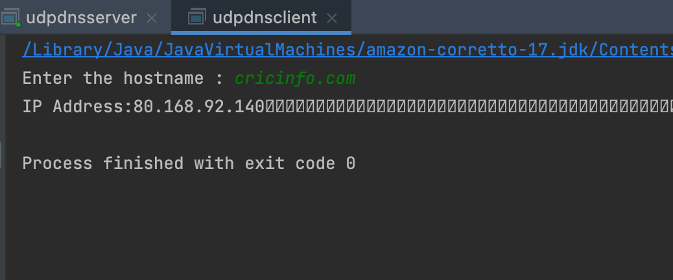

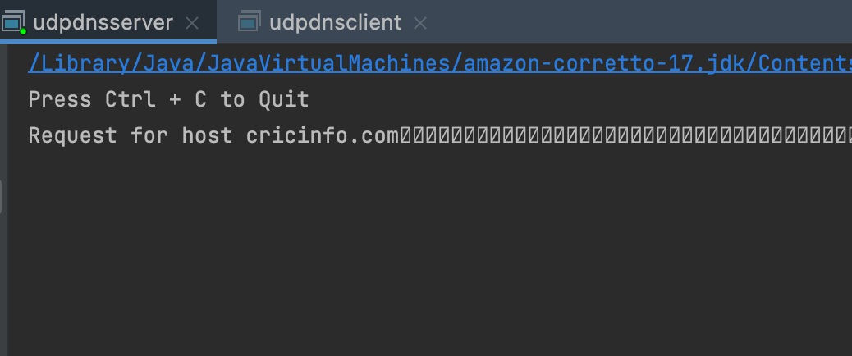

**RESULT :** Applications using TCP and UDP Sockets like DNS, SNMP and File Transfer is done successfully.

**EXPERIMENT-14**

**B.SNMP APPLICATION**

**AIM:** To write a java program for SNMP application program

**PROCEDURE:**

1.    Start the program

 2.  Get the frame size from the use

 3.  To create the frame based on the user request.

 4.   To send frames to server from the client side.

 5.   If your frames reach the server it will send ACK signal to client otherwise it will send NACK signal to client.

6.   Stop the program

**SOURCE CODE:**

import java.io.IOException;

import org.snmp4j.CommunityTarget;

import org.snmp4j.PDU;

import org.snmp4j.Snmp;

import org.snmp4j.Target;

import org.snmp4j.TransportMapping;

import org.snmp4j.event.ResponseEvent;

import org.snmp4j.mp.SnmpConstants;

import org.snmp4j.smi.Address;

import org.snmp4j.smi.GenericAddress;

import org.snmp4j.smi.OID;

import org.snmp4j.smi.OctetString;

import org.snmp4j.smi.VariableBinding;

import org.snmp4j.transport.DefaultUdpTransportMapping;

public class SNMPManager {

Snmp snmp = null;

String address = null;

*               Constructor

*               @param add

*/

public SNMPManager(String add)

{

address = add;

public static void main(String[] args) throws IOException {

 /**

*               Port 161 is used for Read and Other operations

*               Port    162  is     used for   the   trap generation */

SNMPManager client = new SNMPManager("udp:127.0.0.1/161"); client.start();

/**

* OID - .1.3.6.1.2.1.1.1.0 => SysDec

* OID - .1.3.6.1.2.1.1.5.0 => SysName

* => MIB explorer will be usefull here, as discussed in previous article */

 String sysDescr = client.getAsString(new OID(".1.3.6.1.2.1.1.1.0")); System.out.println(sysDescr);

}

 /**

*               get any answers because the communication is asynchronous

*               and the listen() method listens for answers.

*               @throws IOException

*/

private void start() throws IOException {

TransportMapping transport = new DefaultUdpTransportMapping();

snmp = new Snmp(transport);

// Do not forget this line! transport.listen();

}

/**

*               Method which takes a single OID and returns the response from the agent as a String.

*               @param oid

*               @return

*               @throws IOException

*/

 public String getAsString(OID oid) throws IOException {

 ResponseEvent event = get(new OID[] { oid });

return event.getResponse().get(0).getVariable().toString();

}

/**

*               This method is capable of handling multiple OIDs

*               @param oids

*               @return

*               @throws IOException

*/

public ResponseEvent get(OID oids[]) throws IOException { PDU pdu = new PDU();

for (OID oid : oids) {

pdu.add(new VariableBinding(oid));

} pdu.setType(PDU.GET);

ResponseEvent event = snmp.send(pdu, getTarget(), null); if(event != null) {

return event;

} throw new RuntimeException("GET timed out");

}

/**

*               This method returns a Target, which contains information about

*               where the data should be fetched and how.

*               @return

*/

private Target getTarget() {

Address targetAddress = GenericAddress.parse(address);

CommunityTarget target = new CommunityTarget();

target.setCommunity(new OctetString("public"));

target.setAddress(targetAddress); target.setRetries(2);

target.setTimeout(1500);

target.setVersion(SnmpConstants.version2c);

return target;

}}

**OUTPUT:**

Hardware: x86 Family 6 Model 23 Stepping 10 AT/AT COMPATIBLE – Software:

Windows 2000 Version 5.1 (Build 2600 Multiprocessor Free)

**RESULT :** B.SNMP has been implemented  Successfully